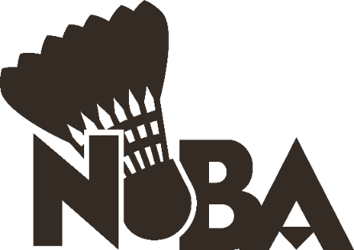
2026 Ontario Winter Games
NOBA Athlete Nomination Form

The Ontario Winter Games is a very exciting event that comes around every few years. This event gathers athletes from all corners of Ontario to compete in a variety of winter sports and represent their district.

When am I required to be available?
You MUST be available for our team practice in North Bay at KTP Racquet Club on Saturday, January 17th (it will be held in the late afternoon or evening). A second practice may be organized, this is TBD. You MUST be available for the Ontario Winter Games from February 19 to February 22. The event will be held in Orillia.

Who is eligible to participate?
All applicants must fit into the Badminton Canada U19 criteria, meaning they are born in 2008 or later. Applicants must also be a current member of a NOBA affiliated club and have been a member of their club for at least 12 months. If the applicant resides in an area where there is no NOBA affiliated club, they may still apply.

How do I apply?
If you are eligible and interested in applying, please submit your application to north.on.bad@gmail.com. You MUST include the following information in your application:
- Your NOBA affiliated club
- Top badminton achievements/results from the last 3 years
- Describe why you would be a worthy selection for the NOBA OWG team

Who selects the team?
The team is selected by the NOBA OWG Head Coach, Kurt Tempelmans Plat. The selection is based on a combination of several factors including attitude, skill, and results.

What are the fees?
Athletes that are selected for the team are required to pay approximately $250-450 to cover their team uniform, travel, and any additional expenses that the Coach and Manager decide upon. Fundraising and sponsorship may be organized to help reduce these fees.

All applications must be submitted to north.on.bad@gmail.com by November 16th at 11:59PM. Selections will be made by the end of November.

