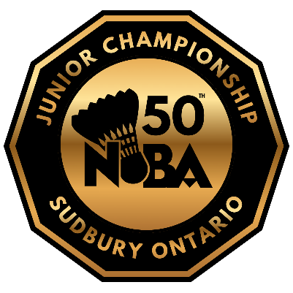
2026 NOBA Junior Championships

The 2026 NOBA Junior Championships is the largest junior club tournament in Northern Ontario. Athletes from all over the district compete for the coveted championship trophies. This year marks the 50th anniversary of the championship, making it one that you will not want to miss!

Date: March 6-8, 2026

Eligibility: Only athletes from clubs that are affiliated with NOBA may register for this tournament.

Schedule:
Friday – 4PM start - U14 Singles
Saturday – 9AM start - U16 & U19 Singles, followed by U14, U16 & U19 Mixed Doubles
Sunday – 9AM start – U14, U16 & U19 Doubles

Location: St Benedict Catholic Secondary School, Sudbury

Age Groups & Events: U14 (2012 or later), U16 (2010 or later), U19 (2007 or later); Boys & Girls Singles,
Boys & Girls Doubles, Mixed Doubles

Entry Fee: $40 for one event, $10 per additional event
Payments should be sent via e-transfer to nobafinances@gmail.com.
*PLEASE include a message with payment saying who the payment is for*
Registration deadline: Sunday, February 16th, 2026*
*Registration may be done individually, or as a club. Send to north.on.bad@gmail.com.*

